29.38: a) 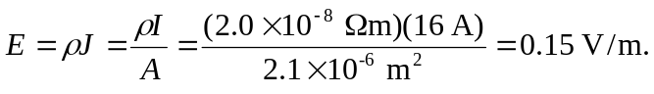
b) 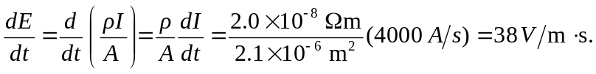
c) 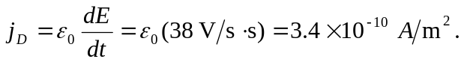
d)
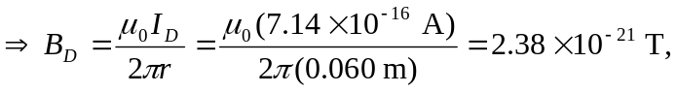and this is a
negligible contribution. 